Guidelines for Applicants, call: Mini-Grant
Dear Users,
These guidelines have been written with a view to improve the clarity and explain certain mechanisms at work when submitting a proposal through the EI.JU system. Information in red is of key importance. Towards the end, the document specifies all the data you are required to provide at each stage of proposal submission. Learning more about them will save your time when filling out the entry forms.
The EI.JU system is a new tool for the processing of calls for proposals under the Excellence Initiative programme, launched in early November 2020; all JU entities are required to carry out their calls for proposals in the system. Given the tool’s existing shortcomings at this early stage, we kindly ask for your understanding and suggest that you read these guidelines to avoid possible mistakes.
Step 1: In order to start filling out a proposal under the Mini-Grant competition, it is prerequisite that you make yourself familiar with the Terms and Conditions and that you have received a special ID number, which will be generated once you have submitted a supporting form from at https://forms.bio.edu.pl/view.php?id=19727
Step 2: Once you have received the ID number, please log in at the EI.JU website using JU credentials (identical with the login details of your employee account) https://strefaid.uj.edu.pl/ . The ongoing calls are displayed under the tab “CURRENT” You can enter the call also by following the link: https://strefaid.uj.edu.pl/Konkurs?kod=1c107fcc-4b88-4c8f-9db7-4c983d72b6c5 Once you have made yourself familiar with the general information on the competition, click on the button: and choose the application type: Mini-Grant
Step 3: The boxes below should be filled out exactly as presented below, by selecting certain values. Unfortunately, the system does not permit us to do it for you in advance.
Academic supervisor: please leave this box blank.
Basic information > Project type: select “Research activity”
Additional information: provide the ID number received in Step 1.
Product: select “Other” and briefly describe (2-4 sentences)
Project results: select “Other” and briefly describe (2-4 sentences)
Attachments: in this case, filling out of this box is not required
Step 4: To display additional boxes in the EI.JU form, click on the blue ‘plus’ icon wherever such an option is available; you can tell it by checking with the blue icon below the box for entering text, as in, for example, Research domains
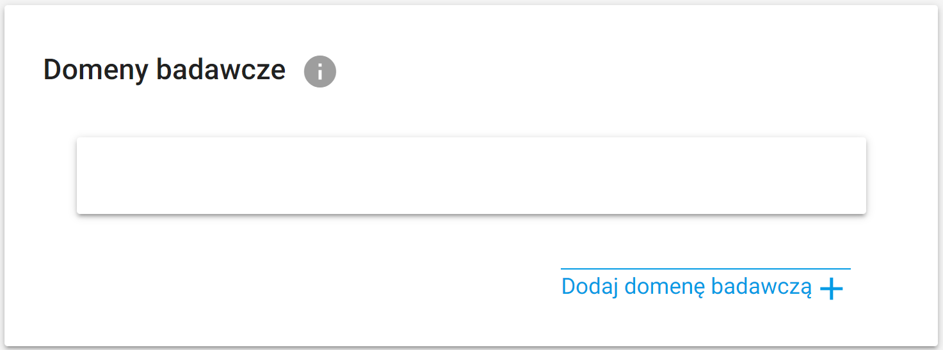

Boxes obligatory when filling out the supporting form
https://forms.bio.edu.pl/view.php?id=19727
Has the applicant, in the last 2 years (from 2018), acted as principal investigator in a research project funded from external sources?* | YES / NO
Number of projects funded from external sources under calls launched at home and abroad, currently carried out, in which the Applicant is acting as principal investigator.* | 0, 1, 2 and more
Degree / Title, Applicant’s name and surname, Host institution, year of receiving doctorate
Doctoral students select, in addition to the above boxes: doctoral school, domain, discipline, current year of study
Information on research career
Information on degrees / titles received, awarding entity, discipline
Academic publications
up to 5 most important works published or accepted for publication (confirmation required) in the year of submitting the application or in the period of 5 years before the year of submitting the application
Information on the most important research achievements
Description of up to 3 most important research achievements in the last 10 years.
Number of publications since 2015
in which the Applicant is named as the first and/or last author or correspondent author
Number of all publications from the list by the Ministry of Science and Higher Education
Number of academic publications published since 2015 by publishers from the list by the Ministry of Science and Higher Education* | With a weighting of 200, 140, 100, 70 and fewer points.
Number of reviewed monographs published since 2015 by publishers from the list by the Ministry of Science and Higher Education* with a specific weighting | First Tier 80 points  Second Tier 400 points
Number of chapters in reviewed monographs published since 2015 by publishers from the list by the Ministry of Science and Higher Education* | First Tier (20 points)  Second Tier (200 points)
h-index (according to WoS)
Number of citations, without self-citations, from the last 5 years (according to WoS)

Boxes obligatory when filling out the entry form:
https://strefaid.uj.edu.pl/Konkurs?kod=1c107fcc-4b88-4c8f-9db7-4c983d72b6c5
Applicant, | Select from a drop-down list; should the system fail to display persons available for selection, please send them requests to log into the system, see Step 2
Academic supervisor | In this case, leave blank
Basic information, Project title, Project title in English, Key words, Key words in English, Project type, Project summary, Project summary in English | For key words, please enter 5 words describing the project.  For project type, please select: research activity
Research domains | Select: structural biology, omics & bioinformatics, cell, systems and translational biology, evolutionary biology and biodiversity research, biology of conflict and cooperation
Domain: Natural sciences | Select: biological sciences, chemical sciences, physical sciences
Scopus subject areas: | Select a subject area according to the All Science Journal Classification
Implementation timeframe | Specify either as a date range or as a number of months
Project aims | Add goals by using the button:
Detailed description Thematic scope of the project | Description of the research to be carried out
Detailed description Project's relevance to the EI.JU program goals, the "4I" principle, and the program indicators | Relevance of the research to at least one goal of the EI.JU: Interdisciplinarity, Internationalization, Innovation, Integration
Detailed description The project’s relevance to the PRA thematic scope | Please state to which BioS domain the project topic is related
Additional information | Please enter the ID number obtained at Step 1 (one number, e.g. 32)
Project implementation plan and schedule: Task name, Task start date, Task end date, Total cost, Currency, Task description, Cost justification | Add items in the schedule by using the button:
Products | Please select “Other” from the drop-down list; fill out the description box with 2 to 4 sentences.
Project results | Please select “Other” from the drop-down list; fill out the description box with 2 to 4 sentences.
Project cost estimate: Type, total cost, currency | You can add more items by using the button:
Total project cost
Annexes | Please leave blank
Additional declarations | Upon selecting YES, please tick the declaration as appropriate; no sending in of the documents related to them is required.
Declaration no 1: | I declare that the project proposal has not been submitted in another competition organised under the strategic program Excellence Initiative at the Jagiellonian University by other PRAs or within university-wide measures.
Declaration no 2: | I accept that the competition results will be published on the website of the Excellence Initiative at the Jagiellonian University, in the relevant PRA / university-wide measure sub-domain, and in the EI.JU, PRA or university-wide measure’s social media.
Declaration no 3: | I accept the general Terms and Conditions and the Competition Terms and Conditions.

